**Signs and symptoms of normal delivery**

Being a woman, you must know about the signs and symptoms of normal delivery. During pregnancy, there are several “must know” things that it all becomes a mess in the brain. Walk step by step with every guide timely. You can make sure that nothing is left out.

Now, pointing out some signs and symptoms of normal delivery. There are a million faces that we see every day. The next day, we see a new set of unique faces. And this goes on. Similarly, their body structures differ from each other.

A step guide is provided here with explanation mentioning signs and symptoms of normal delivery. But no one can guarantee the signs that labor brings to a woman. Every woman experiences labor according to their body and health since there are no “similar signs” associated with delivery. We can’t really plan out the delivery period and when the baby is ready to peep out.

“Which week is normal for delivery?” This question might be revolving in your mind during pregnancy. “How will I understand the signs and symptoms of normal delivery? Will I be able to distinguish between whether the right time has come or not?” We have provided the list of signs and symptoms of normal delivery and how you can cope up with them.

**Which week is normal for delivery?**

Various studies estimate that signs and symptoms of normal delivery listed on internet are very close to reality. For example, a pregnant woman can experience signs that labor is about to begin before 3 weeks from the expected date. Some women might have to wait for one or two more months.

Which week is normal for delivery? The week is considered normal if one easily delivers the baby. Usually, after eight months of pregnancy, chances of delivery start increasing. As the days pass, signs start becoming visible.

Pregnancy lasts for about 40 weeks. For a normal delivery, 34 to 37 weeks are considered as golden period. The golden period is only linked to statistics that the majority of childbirths are recorded between 34 to 37 weeks of pregnancy.

**Baby is coming! Signs and symptoms of normal delivery**

To make sure you are progressing healthily, read below the signs and symptoms of normal delivery.

* **Frequent baby drops**

Anywhere during the pregnancy period for the first-time pregnant women, the pregnant lady may feel that the baby has dropped from the belly and lowered his position in the pelvis. This actually means that the baby has secured a head-down position, commonly known as lightning. Lightning may give a sensation of labor but this is just an indication that the baby is moving. This is common in women who are pregnant for the first time.

When the baby settles in the head-down position, pressure from woman’s diaphragm is released and shifts to pelvis and bladder. This increases the urge of using bathroom whereas an easy breathing follows. It feels like a weight is removed from the chest and it is open to gulp some fresh air in!

* **Regular and rhythmic contractions**

A woman’s uterus contracts regularly in pregnancy. It’s like a rehearsal to participate in the final delivery of the baby. Before labor, the uterus contracts more and intensely than usual times to signify the baby is on the way.

Experts say that true labor involves abdomen getting hard, hard, hard like stone and then relaxing. This process continues starting from the first five minutes to two hours before the baby is born. Signs that labor is going to start begin with contractions.

Remember, contractions are a part of the whole journey. Don’t get afraid in the first months. Make sure you are surrounded by someone in the last weeks.

* **Water Broke**

The fetus grows and develops in the uterus and is surrounded by amniotic fluid. The delivery process involves rupture of the amniotic fluid sac and the woman feels a liquid (amniotic fluid) trickling out. The fluid is colourless and odourless and hence, can be identified easily.

The water may or may not break before delivery. And there are chances that the water breaks a few days before labor. If it doesn’t, the obstetrician will break it during the delivery process. In all, it is a sign that your baby is developed and want to see the world now!

* **Pain and cramps**

Back pain and body cramps are common during pregnancy. After all, a woman is carrying a baby in her body all the time! During head-down positioning of the baby, the pressure on pelvic and rectal areas increases. This may cause transfer of pain from upper body to lower. During labor, pain envelops the body, lower parts attached the most.

* **Bloody vaginal discharge**

As the first stage of labor begins, a woman can notice a bloody discharge that may be pink, brown or blood red in color. This discharge is due to unplugging of the mucous plug that blocks the cervix during pregnancy. It marks the beginning of delivery. The cervix begins to dilate and the mucous plug loosens up discharging itself off.

* **Feeling sudden excitement**

Rather than feeling the same- dull and tired, a woman may feel strong and excited all of a sudden! That’s actually the energy released from the developed baby. The body becomes happy to enter labor time and welcomes it with energy.

The signs and symptoms of normal delivery will allow you to imagine what all is going to happen. You can easily follow the signs and symptoms of normal delivery consulting your doctor once.

**Possibilities of Normal Delivery**

You have increased possibilities of normal delivery, if:

* Your previous delivery was a normal vaginal delivery and no cesarean section was performed.
* You are free from health issues that cause pregnancy complications.
* You gain recommended weight. Problems arise with body gaining extra weight than required.
* You are physically active and strong. Possibilities of normal delivery are increased in working women.
* 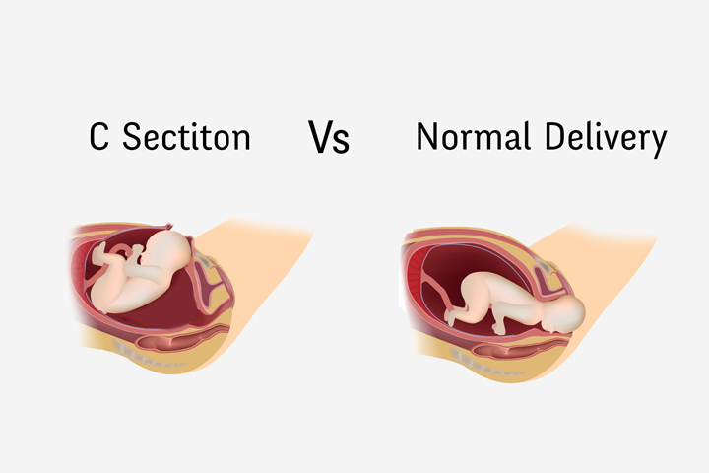Your pregnancy has no serious complications.

**Is normal delivery more painful?**

Is normal delivery more painful? Definitely, yes! A smart solution costs higher in the first place but benefits in future. Similarly, a normal delivery is more painful as compared to a cesarean section but helps in the longer run.

The weak points associated with cesarean delivery causes pain throughout the life, whereas normal delivery causes one-time pain and it’s all over in the delivery room. The question “Is normal delivery more painful?” is hopefully clear. Choose a path that would be easy to handle- for now and for future.

**Tips for normal delivery during pregnancy**

If you haven’t cared much about your body before pregnancy, worry not! Now is the best time to do so. Signs and symptoms of normal delivery will enlighten your path. Follow the tips for normal delivery during pregnancy to minimize complications:

* Plan to give birth at home or a birth centre
* Take perineal massage
* Breech baby? Try out turning techniques else you’ll be offered a cesarean.
* Avoid interventions as much as you can
* Stay active and mobile in the early stages of labor to avoid expansion of labor period
* Stay at home until the final call
* Practice relaxation techniques in advance

Read carefully the tips for normal delivery during pregnancy. To increase possibilities of normal delivery, you need support and strength. Prepare yourself well and practice yoga or other exercises (under your doctor’s advice) to retain your physique. Being lazy in the early stages might interrupt with advanced stages.

**Final words**

The signs and symptoms of normal delivery are provided to increase your knowledge. Just in case you experience something unusual going on, contact your health caretaker and solve your queries. It’s better to ask rather than stay in doubts. Happy pregnancy!